What Is Planet?

The word planet means ‘*wanderer*’. This is because the planets do appear to wander listlessly across the night sky.  The stars also move across the sky from east to west, but relative to each other, they appear fixed. The planets, on the other hand, seem to move relative to the fixed stars in backward and forward directions. This is why they were called *Wanderers*. *We can define Planet as:*

An astronomical body orbiting a star or stellar remnant that is massive enough to be rounded by its gravity, is not massive enough to cause thermonuclear fusion, and has cleared its neighbouring region of planetesimals.

A planet is a large celestial body that revolves around the sun in fixed orbits. Planets do not have any light of their own but reflect the light of the sun. Planets also do not twinkle like stars because they are much closer to us. The earth is also a planet and is the only place we know in the universe to harbour life. **Composition of the solar system**

[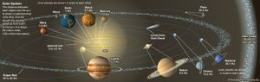](https://cdn.britannica.com/92/95392-050-B5756EB6/orbits-planets-bodies-solar-system.jpg)

[orbits](https://cdn.britannica.com/92/95392-050-B5756EB6/orbits-planets-bodies-solar-system.jpg)

Located at the centre of the solar system and influencing the motion of all the other bodies through its [gravitational](https://www.britannica.com/science/gravity-physics) force is the [Sun](https://www.britannica.com/place/Sun), which in itself contains more than 99 percent of the mass of the system. The planets, in order of their distance outward from the Sun, are [Mercury](https://www.britannica.com/place/Mercury-planet), [Venus](https://www.britannica.com/place/Venus-planet), [Earth](https://www.britannica.com/place/Earth), [Mars](https://www.britannica.com/place/Mars-planet), [Jupiter](https://www.britannica.com/place/Jupiter-planet), [Saturn](https://www.britannica.com/place/Saturn-planet), [Uranus](https://www.britannica.com/place/Uranus-planet), and [Neptune](https://www.britannica.com/place/Neptune-planet). Four planets—Jupiter through Neptune—have ring systems, and all but Mercury and Venus have one or more moons. [Pluto](https://www.britannica.com/place/Pluto-dwarf-planet) had been officially listed among the planets since it was discovered in 1930 orbiting beyond Neptune, but in 1992 an icy object was discovered still farther from the Sun than Pluto. Many other such discoveries followed, including an object named [Eris](https://www.britannica.com/place/Eris-astronomy) that appears to be at least as large as Pluto. It became apparent that Pluto was simply one of the larger members of this new group of objects, collectively known as the [Kuiper belt](https://www.britannica.com/place/Kuiper-belt). Accordingly, in August 2006 the [International Astronomical Union](https://www.britannica.com/topic/International-Astronomical-Union) (IAU), the organization charged by the scientific [community](https://www.merriam-webster.com/dictionary/community) with classifying astronomical objects, voted to revoke Pluto’s planetary status and place it under a new classification called[dwarf planet](https://www.britannica.com/science/dwarf-planet). For a discussion of that action and of the definition of *planet* approved by the IAU, *see* [planet](https://www.britannica.com/science/planet).

[[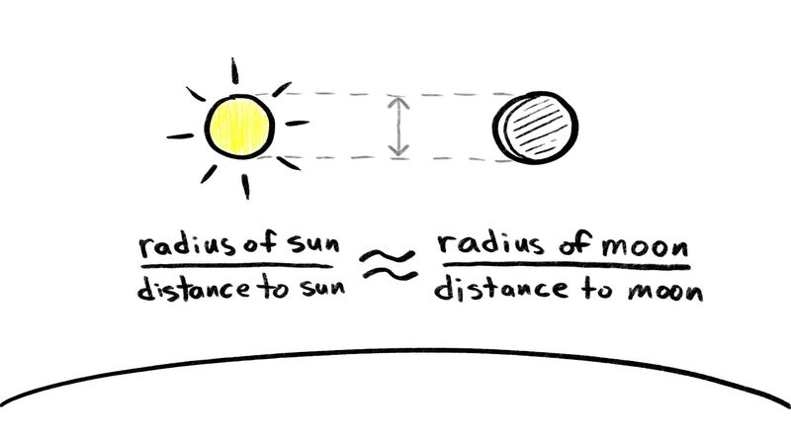](https://www.britannica.com/video/185399/size-solar-system-objects)](https://www.britannica.com/video/185399/size-solar-system-objects)

Understand the relative size of the Sun, the Moon, and other solar system objects

[See all videos for this article](https://www.britannica.com/science/solar-system/images-videos)

Any natural solar system object other than the Sun, a planet, a dwarf planet, or a [moon](https://www.britannica.com/science/moon-natural-satellite) is called a [small body](https://www.britannica.com/science/small-body); these include [asteroids](https://www.britannica.com/science/asteroid), [meteoroids](https://www.britannica.com/science/meteor), and [comets](https://www.britannica.com/science/comet-astronomy). Most of the more than one million asteroids, or minor planets, orbit between Mars and Jupiter in a nearly flat ring called the [asteroid](https://www.britannica.com/science/asteroid) belt. The [myriad](https://www.merriam-webster.com/dictionary/myriad) fragments of asteroids and other small pieces of solid matter (smaller than a few tens of metres across) that populate interplanetary space are often termed meteoroids to distinguish them from the larger asteroidal bodies.

Planets in Solar System

The table below lists the planets in order from the Sun.

|  |  |
| --- | --- |
| 1. Mercury | 5. Jupiter |
| 2. Venus | 6. Saturn |
| 3. Earth | 7. Uranus |
| 4. Mars | 8. Neptune |

Only the first five planets are visible from earth with the naked eye:**Mercury, Venus, Mars, Jupiter, and Saturn**. The other two: **Uranus and Neptune** were discovered only after telescopes were invented.

* The first four planets are made of rock with inner cores made of metal and are called rocky planets.
* The next four are made of gasses like hydrogen and methane and are huge compared to the rocky planets. These planets are called gas giants.

All planets rotate around their own axis just like the earth rotates once in 24 hours. The time a planet takes to revolve around the sun is called it’s **period of revolution**.

* Jupiter rotates almost once every 10 hours.
* Venus takes 243 days to rotate.
* For the earth, it is 365.26 days or 1 year to revolve around the sun.

*The farther a planet is from the sun, the longer it takes to move around the sun.*

What Are Satellites?

Planets have other objects that orbit them. These are called **satellites**. The Moon is the Earth’s satellite. Mercury and Venus are the only two planets without any satellites.

**Planets and their moons**

The eight planets can be divided into two distinct categories on the basis of their densities (mass per unit volume). The four inner, or [terrestrial](https://www.britannica.com/science/terrestrial-planet), planets—Mercury, [Venus](https://www.britannica.com/place/Venus-planet), [Earth](https://www.britannica.com/place/Earth), and Mars—have rocky [compositions](https://www.merriam-webster.com/dictionary/compositions) and densities greater than 3 grams per cubic cm. (Water has a [density](https://www.britannica.com/science/density) of 1 gram per cubic cm.) In contrast, the four [outer planets](https://www.britannica.com/science/outer-planet), also called the Jovian, or [giant](https://www.britannica.com/science/giant-planet), planets—Jupiter, [Saturn](https://www.britannica.com/place/Saturn-planet), [Uranus](https://www.britannica.com/place/Uranus-planet), and Neptune—are large objects with densities less than 2 grams per cubic cm; they are composed primarily of [hydrogen](https://www.britannica.com/science/hydrogen) and [helium](https://www.britannica.com/science/helium-chemical-element) (Jupiter and Saturn) or of ice, [rock](https://www.britannica.com/science/rock-geology), hydrogen, and helium (Uranus and Neptune). The [dwarf planet](https://www.britannica.com/science/dwarf-planet) [Pluto](https://www.britannica.com/place/Pluto-dwarf-planet) is unique—an icy, low-density body smaller than Earth’s [Moon](https://www.britannica.com/place/Moon), more similar to comets or to the large icy moons of the outer planets than to any of the planets themselves. Its acceptance as a member of the Kuiper belt explains these [anomalies](https://www.merriam-webster.com/dictionary/anomalies).

The relatively small inner planets have solid surfaces, lack ring systems, and have few or no moons. The atmospheres of Venus, Earth, and [Mars](https://www.britannica.com/place/Mars-planet) are composed of a significant percentage of oxidized [compounds](https://www.merriam-webster.com/dictionary/compounds) such as [carbon dioxide](https://www.britannica.com/science/carbon-dioxide). Among the inner planets, only Earth has a strong [magnetic field](https://www.britannica.com/science/geomagnetic-field), which shields it from the interplanetary medium. The magnetic field traps some of the electrically charged particles of the interplanetary medium inside a region around Earth known as the [magnetosphere](https://www.britannica.com/science/magnetosphere). Heavy concentrations of these high-energy particles occur in the [Van Allen belts](https://www.britannica.com/science/Van-Allen-radiation-belt) in the inner part of the magnetosphere.

[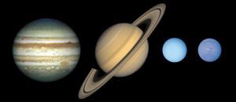](https://cdn.britannica.com/54/145454-050-9756FAF6/Jovian-planets-Jupiter.jpg)

[Jovian planets](https://cdn.britannica.com/54/145454-050-9756FAF6/Jovian-planets-Jupiter.jpg)

The four giant outer planets are much more massive than the terrestrial planets and have immense atmospheres composed mainly of hydrogen and helium. They have no solid surfaces, however, and their densities are so low that one of them, Saturn, would actually float in [water](https://www.britannica.com/science/water). Each of the outer planets has a magnetic field, a ring system, and many known moons, with more likely to be discovered. Pluto has no known rings and only five known moons. Several other Kuiper belt objects and some asteroids also have moons of their own.

Most of the known moons move around their respective planets in the same direction that the planets orbit the [Sun](https://www.britannica.com/place/Sun). They are extremely [diverse](https://www.merriam-webster.com/dictionary/diverse), representing a wide range of [environments](https://www.merriam-webster.com/dictionary/environments). [Jupiter](https://www.britannica.com/place/Jupiter-planet) is orbited by [Io](https://www.britannica.com/place/Io-satellite-of-Jupiter), a body wracked by intense volcanism, while Saturn’s largest [moon](https://www.britannica.com/science/moon-natural-satellite), [Titan](https://www.britannica.com/place/Titan-astronomy)—a body larger than the terrestrial [planet](https://www.britannica.com/science/planet) Mercury—exhibits a primitive [atmosphere](https://www.britannica.com/science/atmosphere) denser than that of Earth. [Triton](https://www.britannica.com/place/Triton-astronomy) moves in a [retrograde](https://www.britannica.com/science/retrograde-motion) orbit around Neptune—that is, opposite to the direction of the planet’s orbit around the Sun—and features plumes of material rising through its [tenuous](https://www.merriam-webster.com/dictionary/tenuous) atmosphere from a surface whose temperature is only 37 kelvins (K; −393 °F, −236 °C).

[**Asteroids**](https://www.britannica.com/science/asteroid)**and**[**comets**](https://www.britannica.com/science/comet-astronomy)

[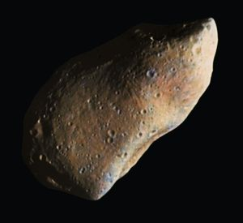](https://cdn.britannica.com/79/74279-050-10F10A64/composite-Gaspra-asteroid-belt-images-spacecraft-flyby-October-29-1991.jpg)

[Gaspra](https://cdn.britannica.com/79/74279-050-10F10A64/composite-Gaspra-asteroid-belt-images-spacecraft-flyby-October-29-1991.jpg)

The [asteroids](https://www.britannica.com/science/asteroid) and [comets](https://www.britannica.com/science/comet-astronomy) are remnants of the planet-building process in the inner and outer solar system, respectively. The [asteroid](https://www.britannica.com/science/asteroid) belt is home to rocky bodies ranging in size from the largest known asteroid, [Ceres](https://www.britannica.com/place/Ceres-dwarf-planet) (also classified by the [IAU](https://www.britannica.com/topic/International-Astronomical-Union) as a dwarf planet), with a diameter of roughly 940 km (585 miles), to microscopic dust particles that are dispersed throughout the belt. Some asteroids travel in paths that cross the orbit of Earth, providing opportunities for [collisions](https://www.britannica.com/dictionary/collisions) with the planet. The rare collisions of relatively large objects (those with diameters greater than about 1 km [0.6 mile]) with Earth can be devastating, as in the case of the asteroid impact that is thought to have been responsible for the massive extinction of species at the end of the [Cretaceous Period](https://www.britannica.com/science/Cretaceous-Period) 65 million years ago (*see* [dinosaur: Extinction](https://www.britannica.com/animal/dinosaur/Extinction#ref225943); [Earth impact hazard](https://www.britannica.com/science/Earth-impact-hazard)). More commonly, the impacting objects are much smaller, reaching Earth’s surface as [meteorites](https://www.britannica.com/science/meteorite). Asteroid observations from Earth, which have been confirmed by spacecraft flybys, indicate that some asteroids are mainly metal (principally iron), others are stony, and still others are rich in organic compounds, resembling the [carbonaceous chondrite](https://www.britannica.com/science/carbonaceous-chondrite) meteorites. The asteroids that have been visited by spacecraft are irregularly shaped objects pockmarked with craters; some of them have retained very primitive material from the early days of the solar system.

[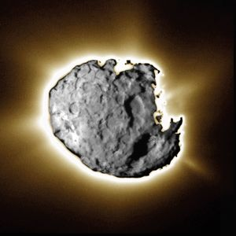](https://cdn.britannica.com/02/81402-050-844DD270/image-nucleus-Comet-Wild-2-spacecraft-comet-January-2-2004.jpg)

[Comet Wild 2](https://cdn.britannica.com/02/81402-050-844DD270/image-nucleus-Comet-Wild-2-spacecraft-comet-January-2-2004.jpg)

The physical characteristics of [comet](https://www.britannica.com/science/comet-astronomy) nuclei are fundamentally different from those of asteroids. Ices are their main [constituent](https://www.merriam-webster.com/dictionary/constituent), predominantly frozen water, but frozen [carbon dioxide](https://www.britannica.com/science/carbon-dioxide), [carbon monoxide](https://www.britannica.com/science/carbon-monoxide), [methanol](https://www.britannica.com/science/methanol), and other ices are also present. These cosmic ice balls are laced with rock dust and a rich variety of organic compounds, many of which are collected in tiny grains. Some comets may have more such “dirt” than ice.

Comets can be classified according to their orbital period, the time it takes for them to revolve around the Sun. Comets that have orbital periods greater than 200 years (and usually much greater) are called long-period comets; those that make a return appearance in less time are short-period comets. Each kind appears to have a distinct source.

The nucleus of a typical long-period comet is irregularly shaped and a few kilometres across. It can have an orbital period of millions of years, and it spends most of its life at immense distances from the Sun, as much as one-fifth of the way to the nearest [star](https://www.britannica.com/science/star-astronomy). This is the realm of the [Oort cloud](https://www.britannica.com/science/Oort-cloud). The comet nuclei in this spherical shell are too distant to be visible from Earth. The presence of the cloud is presumed from the highly elliptical orbits—with eccentricities close to 1—in which the long-period comets are observed as they approach and then swing around the Sun. Their orbits can be inclined in any direction—hence the [inference](https://www.merriam-webster.com/dictionary/inference) that the Oort cloud is spherical. In contrast, most short-period comets, particularly those with periods of 20 years or less, move in rounder, prograde orbits near the plane of the solar system. Their source is believed to be the much nearer [Kuiper belt](https://www.britannica.com/place/Kuiper-belt), which lies in the plane of the solar system beyond the orbit of [Neptune](https://www.britannica.com/place/Neptune-planet). Comet nuclei in the Kuiper belt have been photographed from Earth with large telescopes.

Hear about the band of dust and debris left by comets, which are visible as meteors (shooting stars)

[See all videos for this article](https://www.britannica.com/science/solar-system/images-videos)

As comet nuclei trace out the parts of their orbits closest to the Sun, they are warmed through [solar heating](https://www.britannica.com/technology/solar-heating) and begin to shed gases and dust, which form the familiar fuzzy-looking c